# MED D - Blue MedicareRx (NEJE) - Premium Billing Invoice Requests

Reminders

Invoice Details & Eligibility

Premium Billing Invoicing & Due Dates

Process Care

Requests for an Invoice in an Alternate Format

Frequently Asked Question

Sample - Front of Invoice

Sample - Back of Invoice

Sample - Credit Balance Invoice

Resolution Time

Related Documents

**Description:** This document addresses various Premium Billing Invoice Requests for Blue MedicareRx (NEJE).

|  |
| --- |
| Reminders |

Premium Billing Invoice Requests for **Blue MedicareRx (NEJE)**:

* **New to the plan:** “I haven’t received an invoice yet. Do I still have coverage?”
* **Asking about most recent invoice:** “I haven’t received my current invoice. Can I get a copy?”
* Wanting a copy of a past invoice.
* No longer enrolled in plan, but still has a balance due and hasn’t received an invoice.
* No longer enrolled in plan but has a credit balance and hasn’t received an invoice.
* Receives 100% LIS (Low Income Subsidy) and hasn’t received an invoice.

**Refer to the following:**

* Beneficiaries typically receive their **1st** invoice within **45** days of their enrollment effective date.
* If a beneficiary requests an invoice be sent in an alternate/accessible format, **for example:** Large Print, Braille, or Audio CD, refer to the Requests for an Invoice in an Alternate Format section below.

Top of the Document

|  |
| --- |
| Invoice Details & Eligibility |

Premium Billing is responsible for invoicing beneficiary premiums for prescription drug plan benefits.

* Invoices include the monthly premium amount and any applicable late enrollment penalty.
* Premium Billing handles Invoicing for Blue MedicareRx (NEJE).
* Premium Billing Invoicing begins **AFTER** the beneficiary is set up by Enrollment, and the information reflects in CMS (Centers for Medicare and Medicaid Services) data systems.

Invoices are located within **OneClick**.

* The Invoice is sent within a windowed envelope; the beneficiary’s mailing address will be visible through the plastic window.
* The return address is from **New England Joint Enterprise** with the logo in larger print.
* “**ATTENTION: Important Plan Information**” is printed on the front of the envelope.
* Invoices are subject to USPS (United States Postal Service) mail delivery delays.

Invoices **ARE** sent to **beneficiaries** **who:**

* Are enrolled in Direct Billing and have a balance due (Premium(s) and/or Late Enrollment Penalty amounts).
* Are enrolled in SSA/RRB (Social Security Administration/Railroad Retirement Board benefit) and have a balance due for periods not covered by SSA/RRB **ONLY** for Blue MedicareRx.

Invoices are **NOT** sent to **beneficiaries** **who:**

* Have a $0 balance.
* Have a balance due but have been disenrolled from the plan for more than 4 months.

Top of the Document

|  |
| --- |
| Premium Billing Invoicing & Due Dates |

**Invoicing Dates:**

* **New Enrollees within 45** **days of enrollment** will receive invoice (usually for **two** months or more), refer to [[MED D - Blue MedicareRx (NEJE) - New Enrollee Invoice Grid Job Aid for 2024 (029499)](https://thesource.cvshealth.com/nuxeo/thesource/" \l "!/view?docid=b977a57d-4c10-4099-bf14-907d3cc2472c)](https://thesource.cvshealth.com/nuxeo/thesource/#!/view?docid=b977a57d-4c10-4099-bf14-907d3cc2472c)[.](https://thesource.cvshealth.com/nuxeo/thesource/" \l "!/view?docid=b977a57d-4c10-4099-bf14-907d3cc2472c)
* **Blue MedicareRx -** Invoices are mailed around the **15th**of the month.

**Premiums Due:**

* **Blue MedicareRx** - Considered late if not received by the **1st** of the month.

Top of the Document

|  |
| --- |
| Process Care |

The Customer Care Representative (CCR) must verify whether the beneficiary is eligible to receive an invoice.

When receiving a request for a copy of an invoice, **the CCR will:**

|  |  |  |  |  |  |  |  |  |
| --- | --- | --- | --- | --- | --- | --- | --- | --- |
| **Step** | **Action** | | | | | | | |
| **1** | Determine if the beneficiary receives an invoice based on payment option.   * From the **Main** screen in **PeopleSafe**, click on the **Medicare D Inquiry** tab. * Click on the **Premium History** tab, the **Date Range** will automatically populate. * Set the **Date Range:** To ensure the **Stock ID** section of the **Premium History** screen will display correctly, change the End Date Range field to the end of the next year (**Example:** **12/31/2021**). * Click on the **Show** hyperlink next to the **Billing Cycle & Payment Method**. * Verify the **Stock ID**. | | | | | | | |
| **If the beneficiary’s payment option is…** | | **Then…** | | | | | |
| Direct Bill | | Proceed toStep 2. | | | | | |
| Automatic Credit Card, EFT/ACH (Electronic Funds Transfer/Automated Clearing House), SSA/RRB Deductions | | **Auto Pay options:**   * + A monthly invoice is **NOT** generated.   + A statement that shows account activity (going back to the first month of the prior year) can be provided, anytime at the member’s request.   **Reminder:** SSA/RRB Withholding can take up to 90 days to be approved. The beneficiary is responsible for any premium amounts due **prior** to SSA/RRB Withholding taking effect and would receive an invoice for any outstanding balance accrued **prior** to the SSA/RRB effective date. Copies of these invoices **can** be requested following the remaining steps in this section.  **Note:** Statements are **NOT** meant to serve as a substitute for invoices and are not automatically sent each month to beneficiaries enrolled in auto-pay options. Statements include premium billing account activity going back to the first month of the prior year of the account and cannot be produced for a specific timeframe. If a beneficiary requests a statement, refer to **Statement Requests** section in  [MED D - Blue MedicareRx (NEJE) - Premium Billing General Information, Processes, & Document Index (024894).](https://thesource.cvshealth.com/nuxeo/thesource/#!/view?docid=1e817117-fbc9-4c46-8739-d6457cf8db95) | | | | | |
| **If the beneficiary…** | | **Then…** | | | |
| Has an outstanding balance accrued **prior** to the SSA/RRB effective date and requests a copy of that invoice | | Proceed to Step 2. | | | |
| Does **NOT** request a statement | | Skip to Step 7. | | | |
| **2** | Determine the nature of the invoice request. | | | | | | | |
| **If the beneficiary…** | | | | **Then…** | | | |
| Wants a copy of a past invoice for records  **OR**  Never received a past invoice | | | | ReviewStep 3. | | | |
| Has **NOT** been sent an invoice and they have a balance due/credit balance but is no longer in the plan. | | | | Determine whether the beneficiary still has a balance on the account. Refer to the **Viewing Premium Balance** section in  [MED D - Blue MedicareRx (NEJE) - Premium Billing General Information, Processes, & Document Index (024894).](https://thesource.cvshealth.com/nuxeo/thesource/#!/view?docid=1e817117-fbc9-4c46-8739-d6457cf8db95) | | | |
| **If the beneficiary has…** | | | **Then…** |
| **NO** balance | | | According to our records, you do not have a balance on the account.  Skip to Step 7. |
| A credit balance | | | Skip to Step 5. |
| A balance due | | | Skip to Step 6. |
| Has **NOT** been sent an invoice, and although receives 100% LIS/Extra Help, is concerned a balance may be due. | | | | View the beneficiary’s **Amount After LIS** in **PeopleSafe** to verify whether LIS fully covers the beneficiary’s premium for the current plan year.   * Navigate to the **Medicare D Inquiry** tab > **Premium History** screen. * Under the **Rate Data** section, click the **Show** hyperlink. | | | |
| **If…** | **Then…** | | |
| Yes | Your Extra Help covers 100% of your premium and you have no monthly premium due. Because your Extra Help fully covers your monthly MED D premiums, you will not receive an invoice.  Skip toStep 7. | | |
| No | Your Extra Help does **NOT** cover 100% of your premium. Let me review your account to see if the most recent invoice has been mailed.  Skip to Step 7. | | |
| **3** | Search for the invoice in question in **ONEclick**; refer to [MED D - Viewing Correspondence and Requesting Reprints in PeopleSafe (003379)](https://thesource.cvshealth.com/nuxeo/thesource/#!/view?docid=8d25a915-ad65-4b9e-bfb9-2d0fc62b8b79).  **Note:** If an invoice is not listed for a particular month, no invoice was generated in that month or mailed to the beneficiary.   * Invoices are viewable in ONEclick within 72 hours of being generated. * If the invoice is viewable in ONEclick but the beneficiary has not received it yet, advise the beneficiary that the invoice has been mailed and is subject to USPS mail delivery delays.   **Reminder:** Both invoices and statements are listed in **ONEclick** under the **Event Code** column. Invoices are INV event code and Statements are STMT event code.   * MBI is listed in **ONEclick** for invoices. * MBI is not listed in **ONEclick** for statements. | | | | | | | |
| **If the requested invoice was…** | | | **Then…** | | | | |
| **NOT** sent | | | Research the reason the requested invoice was not sent. | | | | |
| **If the reason the requested invoice was not sent out was because the beneficiary…** | | | **Then…** | |
| Had recently enrolled in the plan | | | The plan is in the process of mailing invoices. It can take 1-2 months before your first invoice is sent. No payment is due until you receive an invoice, and your benefits will not be affected.  **Reminder:** Do **NOT** create RM (Resolution Manager) task requests for invoices on **future dates** or when it is known the beneficiary’s account has **not yet been invoiced** due to recent eligibility change or enrollment with the plan.  **CCR Process Note:** Refer to [MED D - Blue MedicareRx (NEJE) - New Enrollee Invoice Grid Job Aid for 2024 (029499)](https://thesource.cvshealth.com/nuxeo/thesource/#!/view?docid=b977a57d-4c10-4099-bf14-907d3cc2472c). | |
| Was enrolled in an auto-pay option | | | I apologize.No invoice was generated for your account for that particular month because you are enrolled in (Auto-Pay option).  Ask the member if they would like a statement. To request a statement, refer to the **Statement Requests** section in [MED D - Blue MedicareRx (NEJE) - Premium Billing General Information, Processes, & Document Index (024894)](https://thesource.cvshealth.com/nuxeo/thesource/#!/view?docid=1e817117-fbc9-4c46-8739-d6457cf8db95). | |
| Owed no balance | | | You have a $0 balance. Invoices are not mailed to beneficiaries with a $0 balance because no payments are needed for the current invoice month.  Ask the member if they would like a statement. Torequest a statement, refer to the **Statement Requests** section in  [MED D - Blue MedicareRx (NEJE) - Premium Billing General Information, Processes, & Document Index (024894).](https://thesource.cvshealth.com/nuxeo/thesource/" \l "!/view?docid=1e817117-fbc9-4c46-8739-d6457cf8db95)  Skip toStep 7. | |
| Does **NOT** match at least **one** of the following **reasons:**   * Was enrolled in an auto-pay option   **OR**   * Owed no balance   **OR**   * Had recently enrolled in the plan | | | Ask the member if they would like a statement. To request a statement, refer to **Statement Requests** section in [MED D - Blue MedicareRx (NEJE) - Premium Billing General Information, Processes, & Document Index (024894).](https://thesource.cvshealth.com/nuxeo/thesource/#!/view?docid=1e817117-fbc9-4c46-8739-d6457cf8db95) | |
| Sent | | | Confirm that the address reflected on the invoice matches the beneficiary’s current mailing address and state mailing of invoices are subject to USPS mail delivery delays.  **CCR Process Note:** Verify the mailing address in **PeopleSafe** and with the beneficiary to guarantee accuracy. | | | | |
| **If the beneficiary’s mailing address is…** | **Then…** | | | |
| Correct | The plan is in the process of mailing invoices.  **For recently enrolled beneficiaries**, (based on effective date),  It can take 1-2 months before your first invoice is sent. No payment is due until you receive an invoice, and your benefits will not be affected.  **Reminder:** Do **NOT** send RM task requests for invoices on **future dates** or when it is known the beneficiary’s account has **not yet been invoiced** due to recent eligibility change or enrollment with the plan.  **CCR Process Note:** Refer to [MED D - Blue MedicareRx (NEJE) - New Enrollee Invoice Grid Job Aid (029499)](https://thesource.cvshealth.com/nuxeo/thesource/#!/view?docid=b977a57d-4c10-4099-bf14-907d3cc2472c).  Skip to Step 7. | | | |
| **NOT** correct in **PeopleSafe** or on the invoice | Update the beneficiary’s mailing address on the **Medicare D Inquiry** tab and the **Participant** tab. To update contact information, refer to [MED D - Address Changes and Out of Area (OOA) (030149)](https://thesource.cvshealth.com/nuxeo/thesource/#!/view?docid=0ba6dea9-4b34-4351-b06a-ec81046f6c0f).  Your mailing address has been corrected so you should receive future invoices.  Proceed to Step 4. | | | |
| **4** | Send the following **RM Task:**  **Task Category:** Billing/Payment  **Task Type:** Premium Billing Inquiry Medicare D  **Queue:** Finance - Scottsdale Premium Billing  **Reason For Dispute:** STATEMENT REQUEST  **Task Notes: Document the following:**  **“AST017**, Beneficiary requests statement for <list reason(s), detail exactlywhat the beneficiary is disputing>.”  **Reminder:** Only a Statement of Premiums can be generated, refer to [Financial Statement of Cost (SOC) (043264)](https://thesource.cvshealth.com/nuxeo/thesource/#!/view?docid=7049837e-d636-430e-b990-ae0706bd09e9) for medication statements.  **Note:** Statements are **NOT** meant to serve as a substitute for invoices and are not automatically sent each month to beneficiaries enrolled in auto-pay options. Statements include premium billing account activity going back to the first month of the previous year of the account and cannot be produced for a specific timeframe.  If the beneficiary requests a statement of premiums to be faxed instead of mailed to them, contact a Senior/Supervisor.  **Senior Team/Supervisors/Client Support ONLY:** Escalated requests for Premium Billing Statements may have the option to be faxed to the beneficiary. Send the premium billing escalated document inquiry **to this inbox:** [PBMMedDBilling@CVSHealth.com](mailto:PBMMedDBilling@CVSHealth.com). | | | | | | | |
| **5** | According to our records, your account has a **credit balance** of <$xx.xx>.  **Note:** Invoices are not mailed to beneficiaries who have a credit balance and have not been in the plan for more than **6** (six) months.   * + If the beneficiary **asks for a refund**,refer to the **Credit Balances and Premium Refunds** section in [MED D - Blue MedicareRx (NEJE) - Premium Billing General Information, Processes, & Document Index (024894)](https://thesource.cvshealth.com/nuxeo/thesource/#!/view?docid=1e817117-fbc9-4c46-8739-d6457cf8db95).   + If the beneficiary does **NOT** ask for a refund, skip to Step 7. | | | | | | | |
| **6** | According to our records, your account has a **balance** due of <$xx.xx>. Would you like to make a payment today?  **Note:**  Invoices are not mailed to beneficiaries who owe a balance and have not been in the plan for more than 4 months.  Ask the member if they would like a statement. Torequest a statement, refer to **Statement Requests** section in [MED D - Blue MedicareRx (NEJE) - Premium Billing General Information, Processes, & Document Index (024894)](https://thesource.cvshealth.com/nuxeo/thesource/#!/view?docid=1e817117-fbc9-4c46-8739-d6457cf8db95). | | | | | | | |
| **If…** | **Then…** | | | | | | |
| Yes | I would be happy to help with that.  **Refer to applicable work instruction:**   * + [MED D - Blue MedicareRx (NEJE) Premium Billing Credit Card Single-Sign-On (SSO) Processes (017576)](https://thesource.cvshealth.com/nuxeo/thesource/#!/view?docid=53335578-e3bd-4ecc-a6de-0fe9c1e3d27e)   + [MED D - Blue MedicareRx (NEJE) Premium Billing E-Check/EFT Single-Sign-On (SSO) Processes (028699)](https://thesource.cvshealth.com/nuxeo/thesource/#!/view?docid=5d43393c-71b0-4ed1-a3e3-a6247be1e5de)   Proceed to Step 7. | | | | | | |
| No | I understand.If you change your mind at a future date, please contact Customer Care and we will be happy to assist you.  Proceed to Step 7. | | | | | | |
| **7** | Ask if there are any other questions.   * Address any other issues and document/close the call according to existing policies and procedures; refer to [MED D - Call Documentation Including Viewing and Adding Comments in PeopleSafe (067665)](https://thesource.cvshealth.com/nuxeo/thesource/#!/view?docid=e9cdb772-9c04-4e42-b87a-ae4d2c2e1f62). * Log Activity1327 = Premium Billing. | | | | | | | |

Top of the Document

|  |
| --- |
| Requests for an Invoice in an Alternate Format |

If a beneficiary requests an invoice in an alternate/accessible format (Large print, Braille, or Audio CD), **perform the following steps:**

|  |  |
| --- | --- |
| **Step** | **Action** |
| **1** | * In what accessible format do you need the invoice? (Large print, Braille, or Audio CD) * I would be happy to submit your request.   **Submit the following RM Task:**  **Task Category:** Customer Care Internal Process  **Task Type:** Account Executive Consideration  **Queue:** CC Internal Processes – Client Support  **Notes:**  **Document the following:**   * Beneficiary’s Name * Beneficiary’s Mailing Address * Participant External ID (Member ID) * Letter type * Original Letter Date * Alternate/Accessible Format * One-time Request * Confirmed the beneficiary received the original letter   Proceed to Step 2. |
| **2** | Explain next steps.  You should receive the requested format of your letter within 20 business days.  When you receive future mailings, please contact us again to request the invoice in an alternate/accessible format and we’ll be happy to assist. Thank you. |

Top of the Document

|  |
| --- |
| Frequently Asked Question |

The following table will assist in addressing a Frequently Asked Question **regarding Invoices:**

|  |  |  |
| --- | --- | --- |
| **#** | **Question** | **Answer** |
| **1** | **I didn’t receive an Invoice in the mail.** | **CCR Process Note:** Locate the Invoice in **ONEclick**.  **Note:** If there is **NOT** an Invoice in **ONEclick**, refer to **Step 2** within the Process Care section.  Our records show the letter was mailed on <mm/dd/yyyy> to the following address, <insert address here>.   * The Invoice is sent within a windowed envelope; your mailing address would be visible through the plastic window. * The return address is from **New England Joint Enterprise** with the logo in larger print. * “**ATTENTION: Important Plan Information**” is printed on the front of the envelope. * Invoices are subject to mail delivery delays with the USPS.   **CCR Process Note:** If the Invoice was sent to the incorrect address, verify address on account and update if applicable, then refer to **Step 3** and **Step 4** within the Process Care section. |

Top of the Document

|  |
| --- |
| Sample - Front of Invoice |

The sample below is an illustration of the **front**of a Premium Billing Invoice.

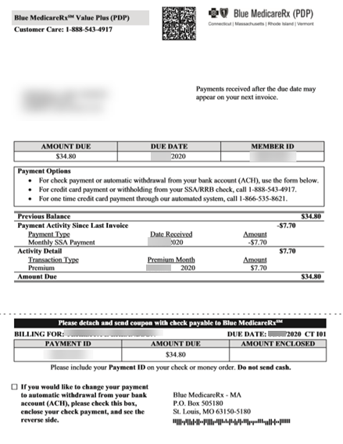

Top of the Document

|  |
| --- |
| Sample - Back of Invoice |

The sample below is an illustration of the **back**of a Premium Billing Invoice.

**Items to note:**

* Notation regarding Automatic Payment which indicates that the entire balance up to $300 will be withdrawn from the beneficiary’s bank account or charged to his/her credit card.
* For an amount due over $300, the beneficiary will be contacted before the deduction/charge is made.

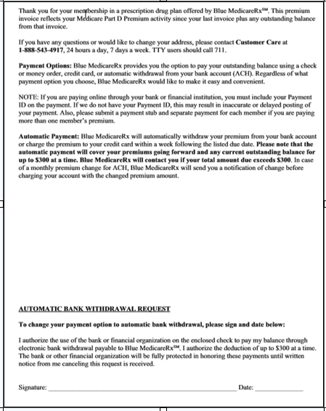

Top of the Document

|  |
| --- |
| Sample - Credit Balance Invoice |

The samples below show Premium Billing Invoices for beneficiaries with a credit balance on their accounts.

**Items to note:**

* CREDIT BALANCE replaces the AMOUNT DUE heading.
* For Blue MedicareRx beneficiaries, the message “NO PAYMENT DUE” displays at the top, reminding they do not owe a payment.

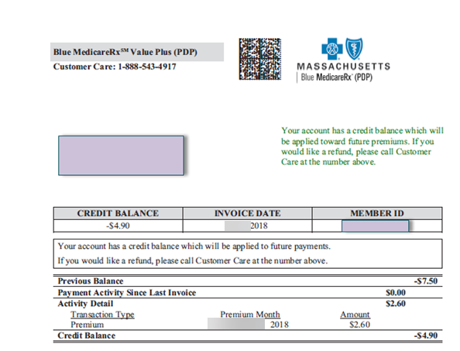

Top of the Document

|  |
| --- |
| Resolution Time |

Resolution times vary by the specific situation.

**CCR Process Note:** Resolution times for Premium Billing RM Tasks are contingent on the issue. Premium Billing will research and provide a resolution for all Premium Billing related activity within 10 business days. **This does NOT include:** Statement letters, refunds and social security refunds. Any issue requiring review from other internal departments can cause a delay in Premium Billing addressing the concern with the standard timeframe of 10 business days.

Premium Billing RM Task requests for a statement letter can take up to 21 business days. Beneficiaries should allow 21 business days for Premium Billing refund checks. Social Security set up and refunds may take up to 90 days.

Refer to Premium Billing Processing Time section in the [MED D - Blue MedicareRx (NEJE) - Premium Billing General Information, Processes, & Document Index (024894)](https://thesource.cvshealth.com/nuxeo/thesource/#!/view?docid=1e817117-fbc9-4c46-8739-d6457cf8db95) and [RM Task Turn Around Time Job Aid (027873)](https://thesource.cvshealth.com/nuxeo/thesource/#!/view?docid=863acba1-4370-4da9-9f6b-4cadf8633fbf).

Top of the Document

|  |
| --- |
| Related Documents |

**Parent Document:** [CALL-0048: Medicare Part D Customer Care Call Center Requirements-CVS Caremark Part D Services, L.L.C.](https://policy.corp.cvscaremark.com/pnp/faces/DocRenderer?documentId=CALL-0048)

**Grievance Standard Verbiage:** Grievance Standard Verbiage (for use in Discussion with Beneficiary) section in [MED D - Grievances in MedHOK (007931)](https://thesource.cvshealth.com/nuxeo/thesource/#!/view?docid=71364003-a41f-4b84-be24-1e85435462b2).

[Customer Care Abbreviations, Definitions, and Terms Index (017428)](https://thesource.cvshealth.com/nuxeo/thesource/#!/view?docid=c1f1028b-e42c-4b4f-a4cf-cc0b42c91606)

[Universal Medicare D - Consultative Call Flow (CCF) Process (095822)](https://thesource.cvshealth.com/nuxeo/thesource/#!/view?docid=c954b131-7884-494c-b4bb-dfc12fdc846f)

[MED D - Blue MedicareRx (NEJE) - Premium Billing General Information, Processes, & Document Index (024894)](https://thesource.cvshealth.com/nuxeo/thesource/" \l "!/view?docid=1e817117-fbc9-4c46-8739-d6457cf8db95)

Top of the Document

Not to Be Reproduced or Disclosed to Others Without Prior Written Approval

**ELECTRONIC DATA = OFFICIAL VERSION / PAPER COPY = INFORMATIONAL ONLY**